# Site Plan for Final project WDD230

**Name:** Wilson Omar Romero Baños

**Site Name:** Heaven Doors Inn

**Website:** heavendoorsinn.com

**Logo:**



**Site Purpose:** Provide a brief statement about the purpose of the website drawing upon the client's functional specifications, the industry, and any fictitious but viable goals that you deem to be reasonable.

The purpose of the site is to let the people that travels to Bethesda temples know the benefits they can get while they stay in our Hotels in an informative and very descriptive way, to offer them a way to be in touch with our company and to show them the great experience they will have if they reserve in our hotels.

**Target Audience:** Research who the website visitors will be by discovering the industry, visiting similar sites and asking your friends, family or acquaintances through an informal survey about the industry. You may elect to develop personas (Links to an external site.) for the distinct type of site visitors. This section should describe the target audience being judicious about the selection of the most plausible demographics.

Heaven Doors Inn website is designed for the people traveling to Bethesda temples. The target audience are people of any age, members of the Church of Jesus Christ of Latter Day Saints or family and friends that are not part of the church so they can have an amazing experience while staying in a church members environment.

**Site Map:** The site map is a sketch of all the website pages and references. It should illustrate the relationship between those pages.

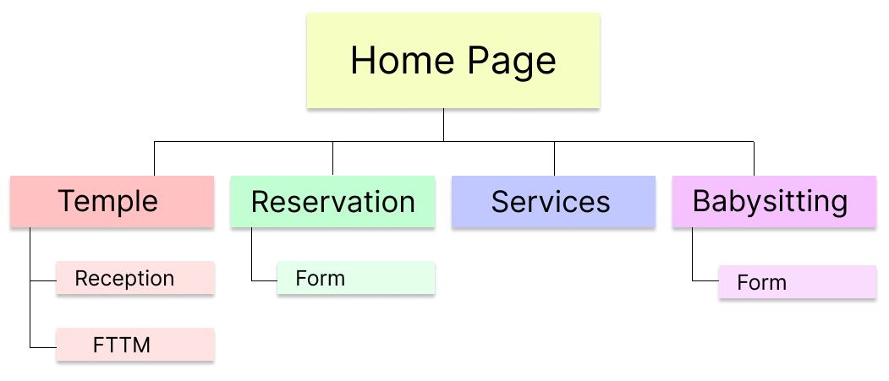

**Color Scheme:** The color scheme refers to the carefully selected site colors that reflect the organization's purpose and trademark colors. Note the organization does not have established colors for brand identity. The planning document defines the color scheme through a color palette that labels color style definitions and swatches for site elements.

The objective is to keep the website as simple as possible so I will use just basic colors so I can have a broad of colors to use as call to action and contrast.

|  |  |  |
| --- | --- | --- |
| Title | This will be the title color | #D4AF37 |
| Backgrund | Background | #f1f1f1 |
| Shadows | Shadow color | #a8a8a8 |
| Headers | Headers color | #292929 |
| Paragraph | Paragraph color | #474747 |
| Call to action | Call to action color | #375cd4 |

**Typography:** The project specifications require that you utilize the directory of open source designer web fonts provided by Google Fonts. The typography section of the planning document provides examples of the fonts to be used and where they are to be applied.

For the website I will use 2 different typography stiles:

Rouge Script for the headers and title:

https://fonts.google.com/specimen/Rouge+Script

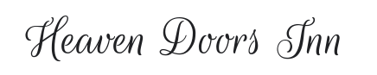

Roboto for the paragraph and rest of the text:

https://fonts.google.com/specimen/Roboto



**Wireframe Sketches:** Produce wireframe sketches of at least the home page of the site design considering the purpose, specifications, and target audience. You should include sketches for small, medium, and large views respectively meaning smart phon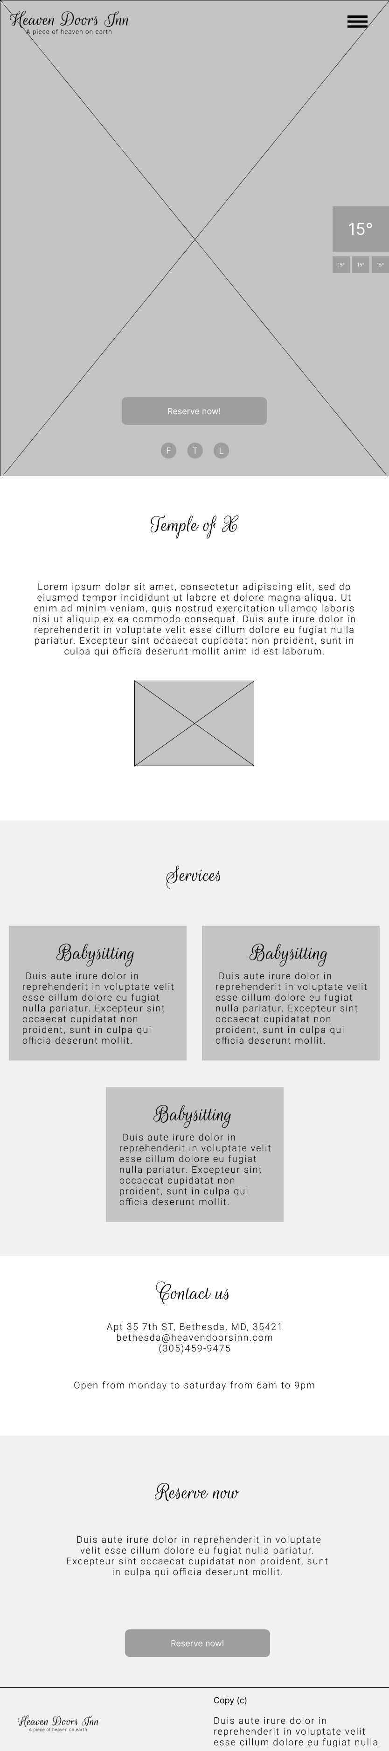es, tablets, and large width monitors

